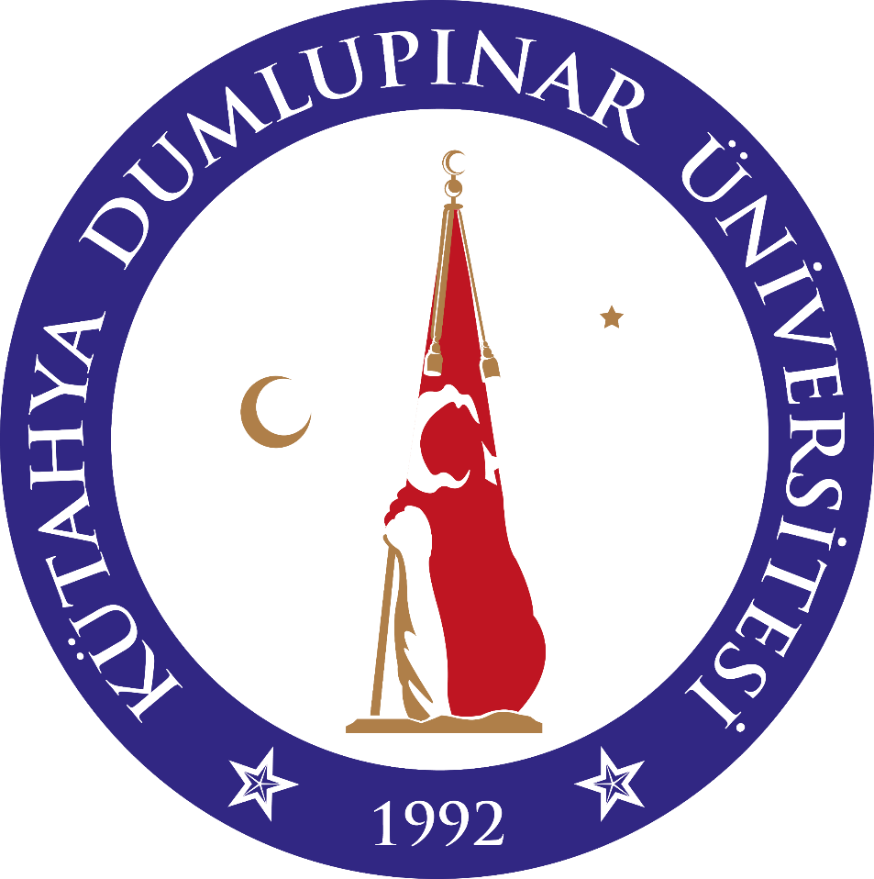
III. INTERNATIONAL STAFF TRAINING WEEK:
"Future-Ready Academia: Digitalization Across Disciplines"

12-16.05.2025

Surname:
Name:
Title:
E-mail:
Home Institution:
Country:
Department/Unit/Office:
Short Professional Profile (your main tasks and duties):
Please indicate the contribution that can provide (presentation, seminar and etc.):
If you have any special dietary requirements, please indicate:

